BACANI, JANVERLY MHAY O.

ACTIVITY: THINIK IN BOXES

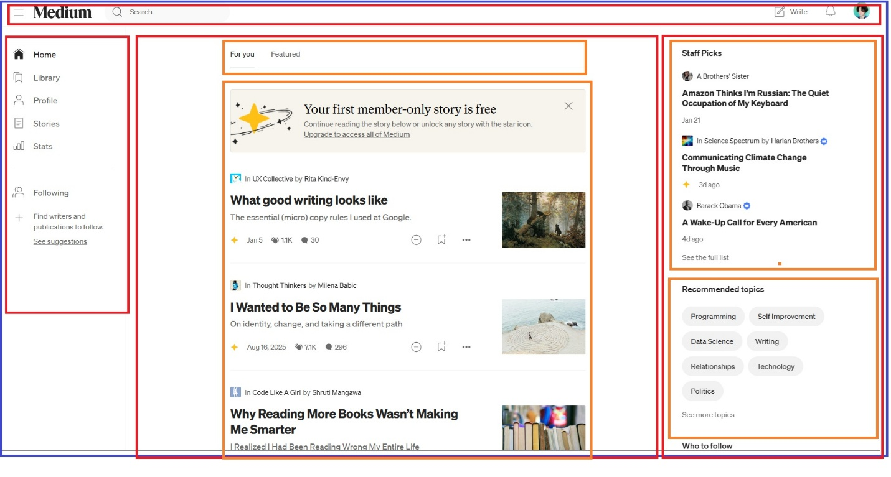

Blue Box represents the entire website or Webpage container. It covers the full layout and serves as the main wrapper where all other elements of the website are placed.
Red boxes are the major sections of the website. Each red box groups related content together, such as headers, navigations, main content section, etc. Tis section helps organize the webpage and define its overall structure.
Orange boxes are the actual content inside each section. These include elements such as text, images, videos, or lists. They are the smallest building blocks and contain the information that users see and interact with.

